**COMP 3069 -- Computer Graphics**

**Assignment 2**

(Due time: *4pm, Friday, 21 November 2018* *-- UK time*)

*There are* ***THREE*** *questions in total in this assignment. You need to* ***answer all three*** *questions. For the* ***first two******questions*** *you answer, each of them cost* ***40 credits****; and for the* ***last question*** *you answer, it would only cost* ***20 credits****. The distribution of marks are arranged in such a way because we take into consideration some possibly happening situation that students might not have enough time to do all three questions.*

**PART I: Written Part**

**Question 1.** *Viewing Coordinate System and Lighting.* ***(40 or 20 credits)***

(a) A viewing coordinate system UVN is set up with the ***eye*** at A(3,1,2), ***lookat*** at B(0,1,2), and 'up' vector is the negative y direction. Now, P and Q are two points in the world coordinate system XYZ. And P' and Q' are the coordinates of P and Q, respectively, in the viewing coordinate system UVN.



(a.i) Suppose that P locates at (2,3,-1) in the world coordinate system. What is the coordinates of P' in the viewing coordinate system?   
(Note that you need to **show the intermediate matrices** you use for the corresponding calculations.)

(a.ii) Suppose that Q' locates at (6,5,8) in the viewing coordinate system. What is the coordinates of Q in the world coordinate system?   
(Note that you need to **show the intermediate matrices** you use for the corresponding calculations.)

(b) Explain what ambient light, diffuse light, and specular light are, respectively. And describe how to compute the light intensity at each point of the reflected surface for each of the above three kinds of light.

**PART II: Programming Part (Two questions in total)**

Kindly remark that for obtaining full credits of the following two questions in Programming Part, you are required to write programs giving correct output, and the programming code need to be with good readability and good writing style (eg. modularity, good object-oriented structure, well-commented, etc.)

**Question 2.** *Pentagon Snowfake (PS).* ***(40 or 20 credits)***

In this question, you are required to write a program outputting the pentagon snowfake (PS) as described in the following. The initial configuration of PS is a regular pentagon with one unit long which is shown as follows in Figure 1.

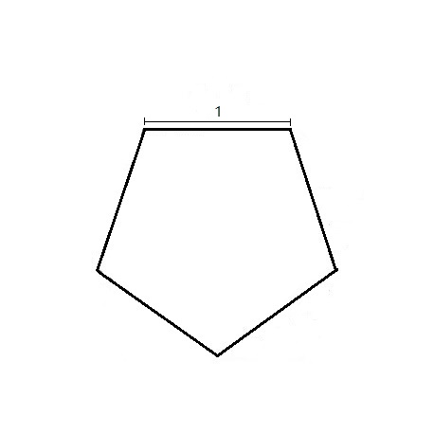

Figure 1. A regular pentagon with one unit long.

We then perform further subdivision to the initial pentagon. For the 1st subdivision of PS, an isosceles triangle is added at the center of each side following the rule as illustrated in Figure 2.

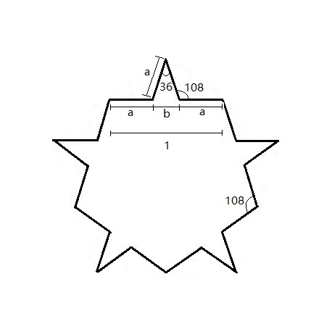

Figure 2. The 1st subdivision of PS.

Note that $\frac{a}{b}$ is the golden section.

Then, for the 2nd subdivision, an isosceles triangle is again added at the center of each side of the 1st subdivision of PS as illustrated in Figure 3.

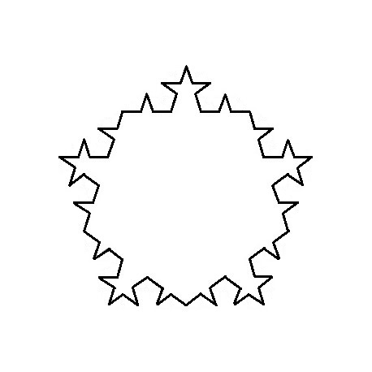

Figure 3. The 2nd subdivision of PS.

We repeat the subdivision process, and after one more round of subdivision, the 3rd subdivision of PS is obtained as shown in Figure 4.

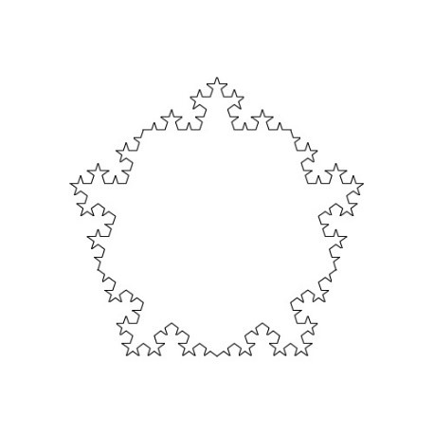

Figure 4. The 3rd subdivision of PS.

Your work is to design a recursive procedure for drawing the kth subdivision of PS. The initial state is a regular pentagon and then use “+” button to increase each time one subdivision, and use “-” button to go back one subdivision each time.

**Question 3.** *Animation.* ***(40 or 20 credits)***

In this question, you are required to produce an animation as follows. There is a ball with a specific texture on its surface (each student specifies a different texture here) in the space. The ball moves forward horizontally around a circle with constant velocity. In the vertical direction, it falls naturally according to the gravity of earth to reach the floor and bounce back to the original height periodically. then use “+” button to increase the horizontal velocity of the ball, and use “-” button to decrease the horizontal velocity of the ball (note that for obtaining full credits, the velocity may decreased to negative values, which means that the ball changes the motion direction).

**Submission instructions:**

1. Name your answer file for Question 1 as Question1.pdf.
2. Place the program files (see 3 below) for Question 2 and Question 3 in folders with name Question2 and Question3, respectively.
3. Your program and source code need to be submitted. Due to the upload limitation of Moodle, you need to upload the following files:
   1. “.cpp”, “.h”, and other related files
   2. an executable .exe file (using release function)
   3. a screen shot of the output of your program for each programming question.
4. If your code is not executable, you may be required to give an in-class demonstration.
5. Kindly zip all your files as CG18_StudentName_StudentID_A2.zip for uploading to Moodle.

**Plagiarism warning**

The report and code will be uploaded and checked by Turnitin, do not copy the code from any open source websites.